**1.**

# A Python program that calculates (then outputs) the sum of all even

# integers between 4 and 90 inclusive.

# NAMED_CONSTANTS for lower and upper range (4, 90).

##

# Written By: Sam Graham, Tampa, FL, USA

# Written On: 2/9/2019

##

LOWER_RANGE = 4

UPPER_RANGE = 90

sum = 0

for i in range(LOWER_RANGE, UPPER_RANGE + 1) :

if i % 2 == 0 :

sum += i

print(sum)

**Output:**

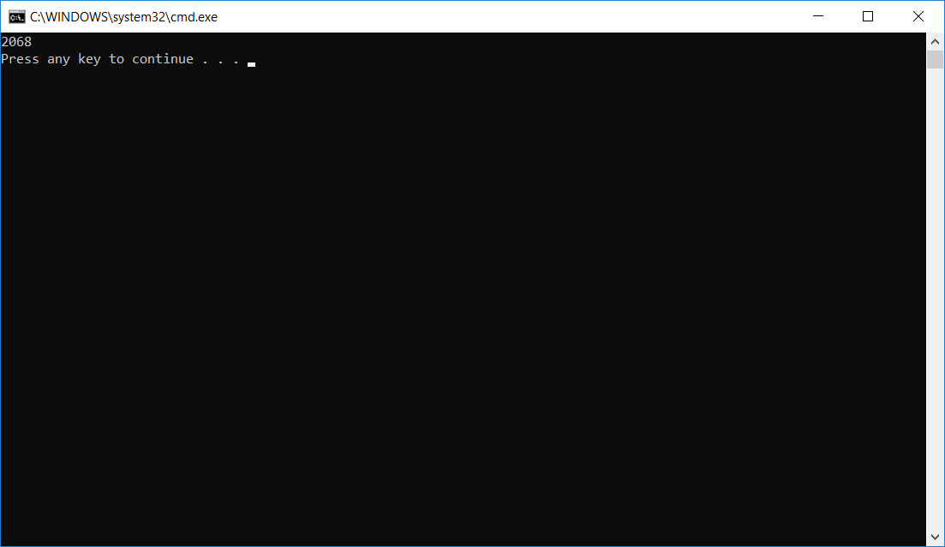

**2.**

# A Python program that lets a user enter floating point numbers until the

# sentinel value of 0 is entered. After the user has finished entering

# numbers, your program should output the following:

# Number of numbers entered.

# Sum of numbers entered.

# Average of the numbers entered.

# Smallest number entered.

# Largest number entered.

##

# Written By: Sam Graham, Tampa, FL, USA

# Written On: 2/9/2019

##

counter = 1

sumOfNums = 0

userInput = float(input("Enter a number, or 0 to quit: "))

smallestNum = userInput

largestNum = userInput

while userInput != 0 :

sumOfNums += userInput

if smallestNum > userInput :

smallestNum = userInput

if largestNum < userInput :

largestNum = userInput

userInput = float(input("Enter another number, or 0 to quit: "))

if userInput == 0 :

break

counter += 1

print()

if counter == 1 :

print("You didn't input any numbers")

else :

print("You entered %d numbers before quitting" % counter)

print("That adds up to %f" % sumOfNums)

print("Which averages out to %f" % (sumOfNums / counter))

print("The smallest number entered was %f" % smallestNum)

print("The largest number entered was %f" % largestNum)

**Output:**

